CSA0619-Design and Analysis of Algorithm
TOPIC-4
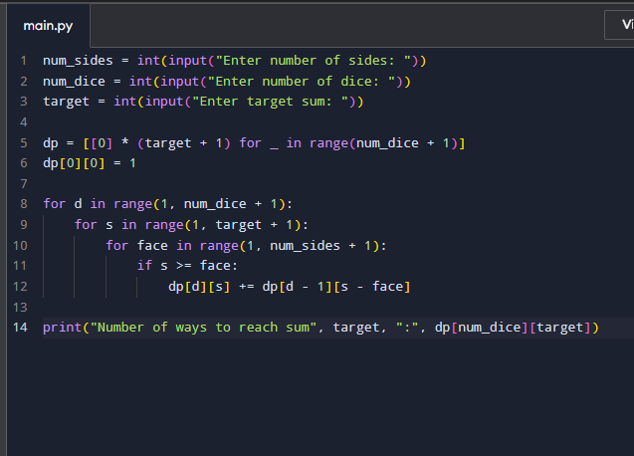
1

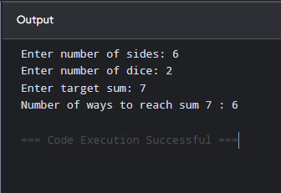

Time Complexity: O (num_dice × target × num_sides)
Space Complexity: O (num_dice × target)

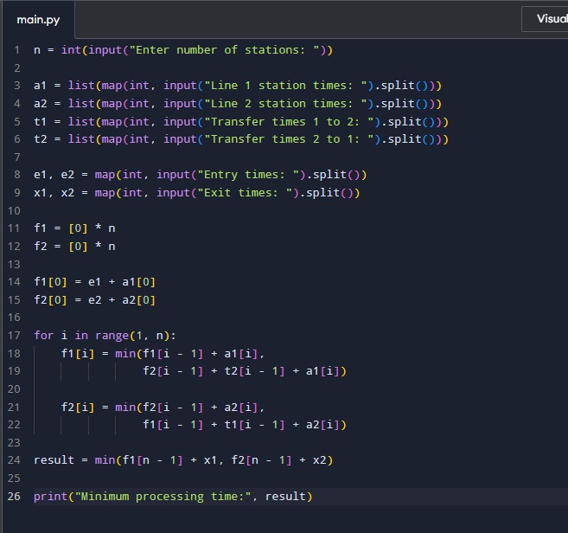
2,

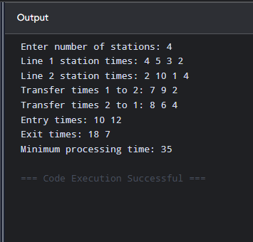

Time Complexity: O(n)
Space Complexity: O(n)

3, 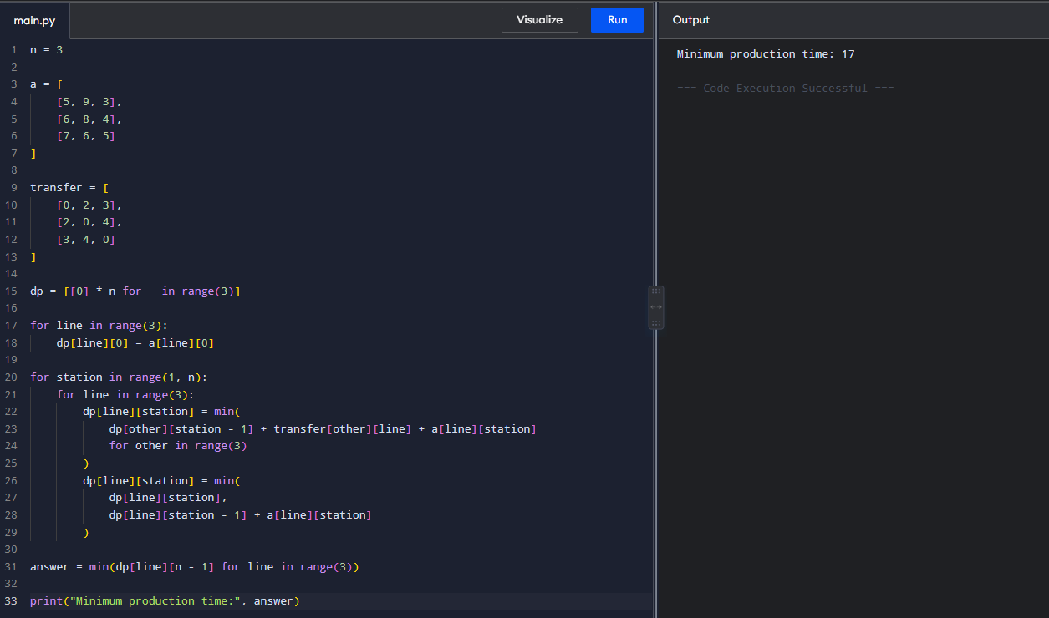
Time Complexity: O(n)
Space Complexity: O(n)
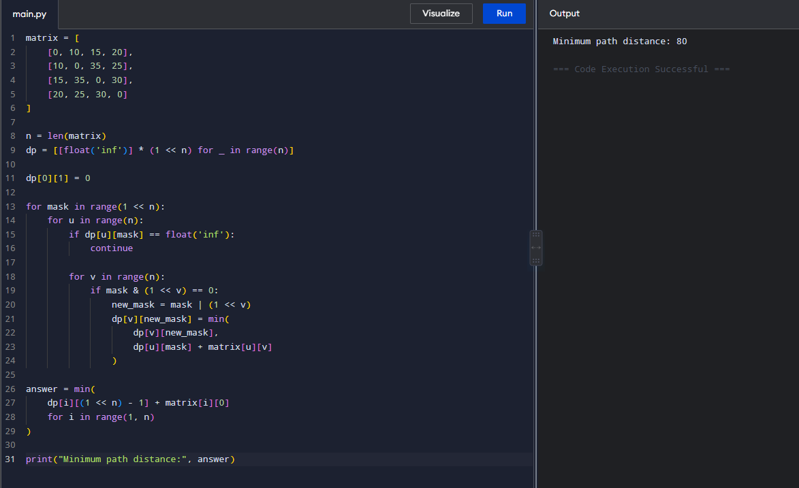
4,

Time Complexity: O(n² × 2ⁿ)
Space Complexity: O(n² × 2ⁿ)
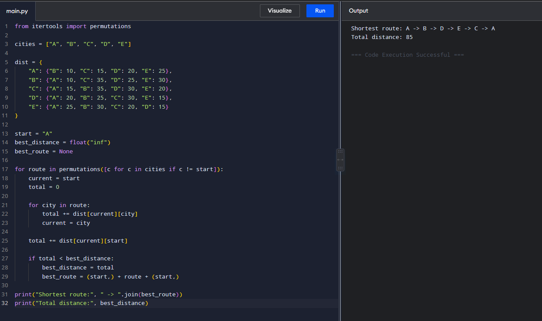
5,

Time Complexity: O(n!)
Space Complexity: O(n!)

6, 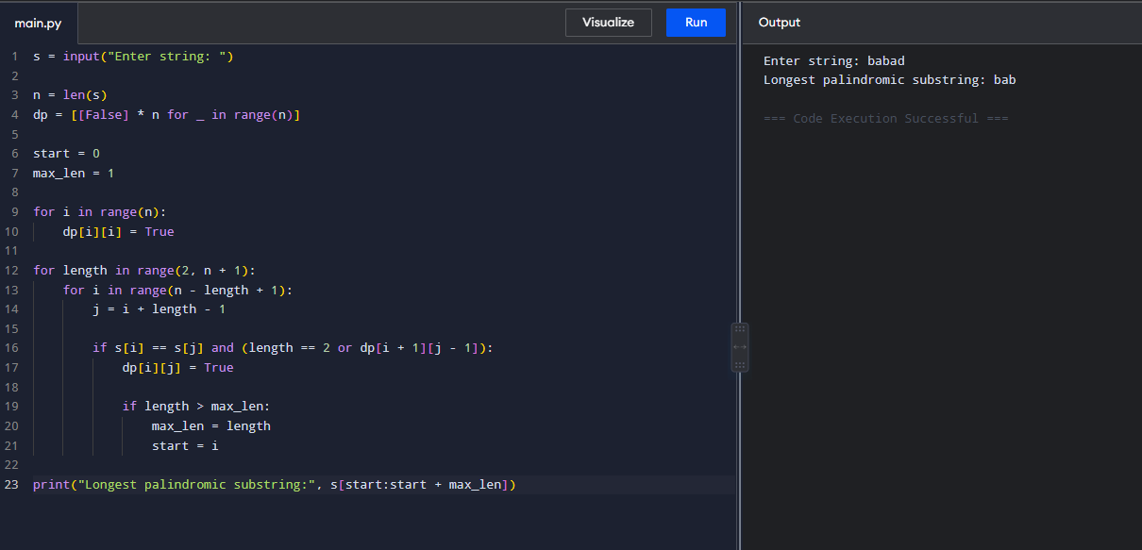
Time Complexity: O(n²)
Space Complexity: O(n²)

7, 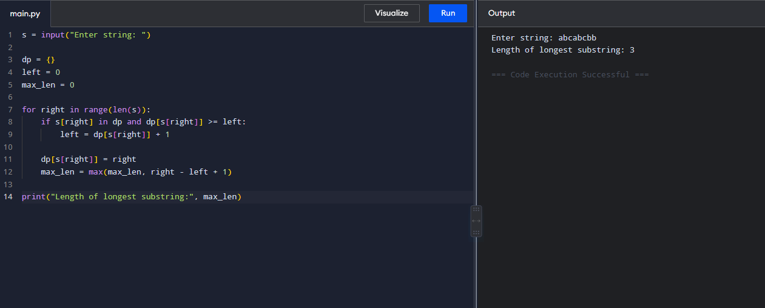
Time Complexity: O(n)
Space Complexity: O(n)

8, 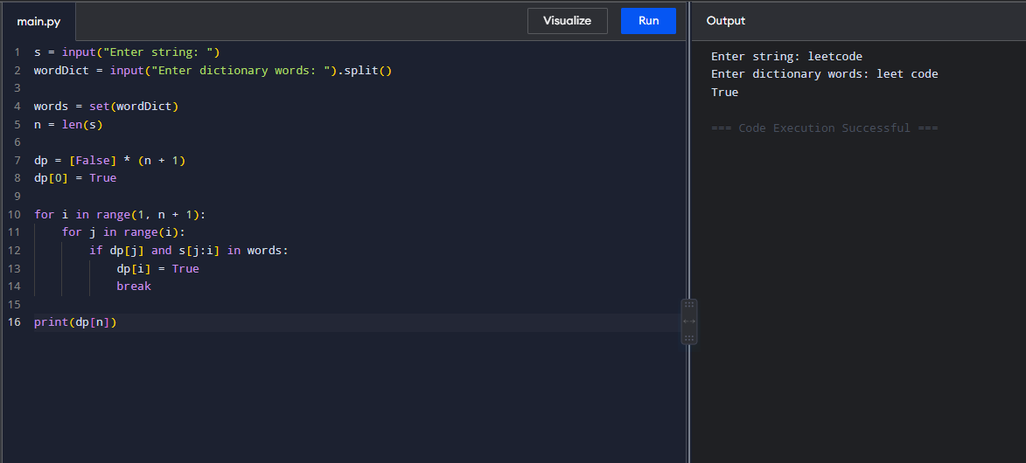
Time Complexity: O(n²)
Space Complexity: O(n)

9, 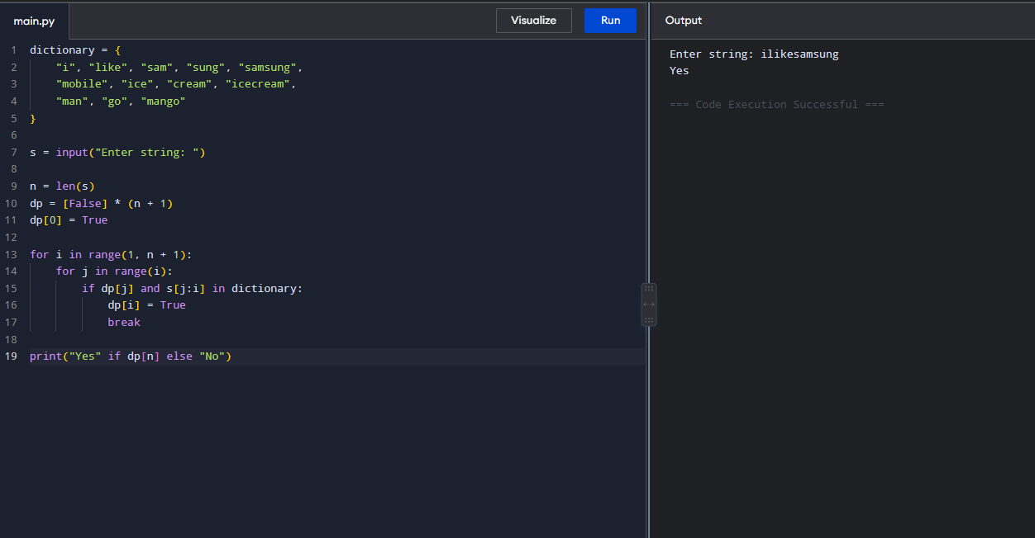
Time Complexity: O(n²)
Space Complexity: O(n)

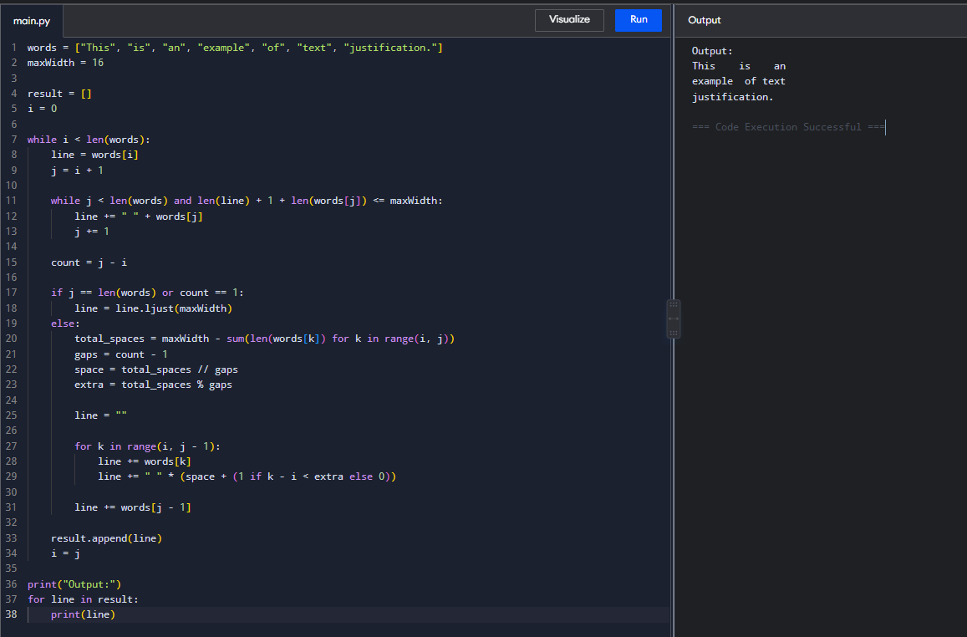
10,

Time Complexity: O(n)
Space Complexity: O(n)
11, 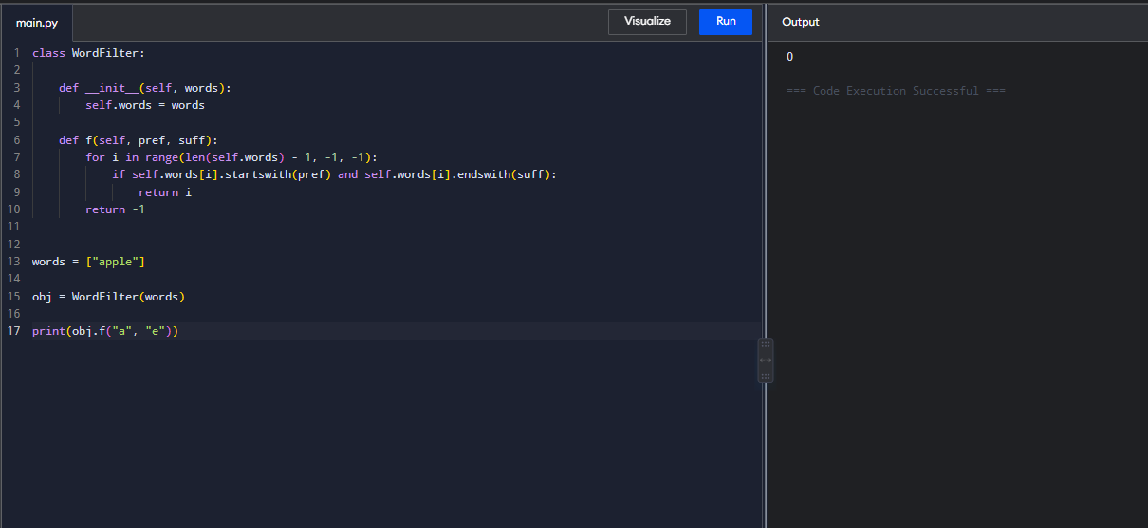
Time Complexity: O(n × L)
Space Complexity: O(n × L)

12, 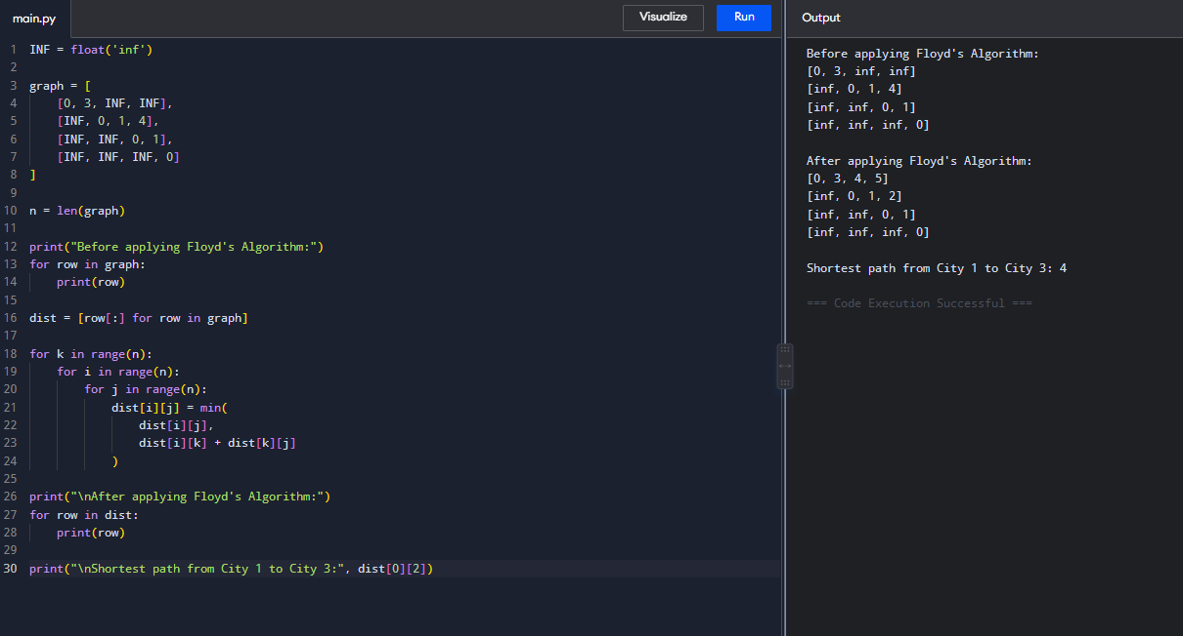
Time Complexity: O(n³)
Space Complexity: O(n²)

13, 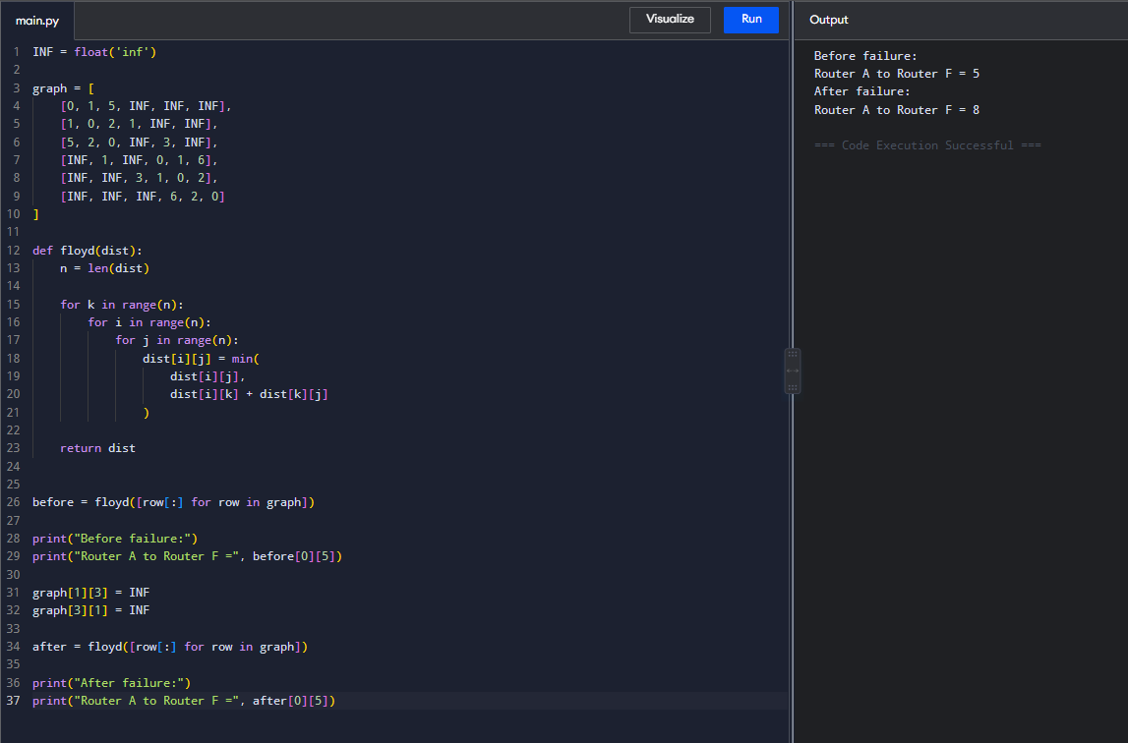
Time Complexity: O(n³)
Space Complexity: O(n²)

14, 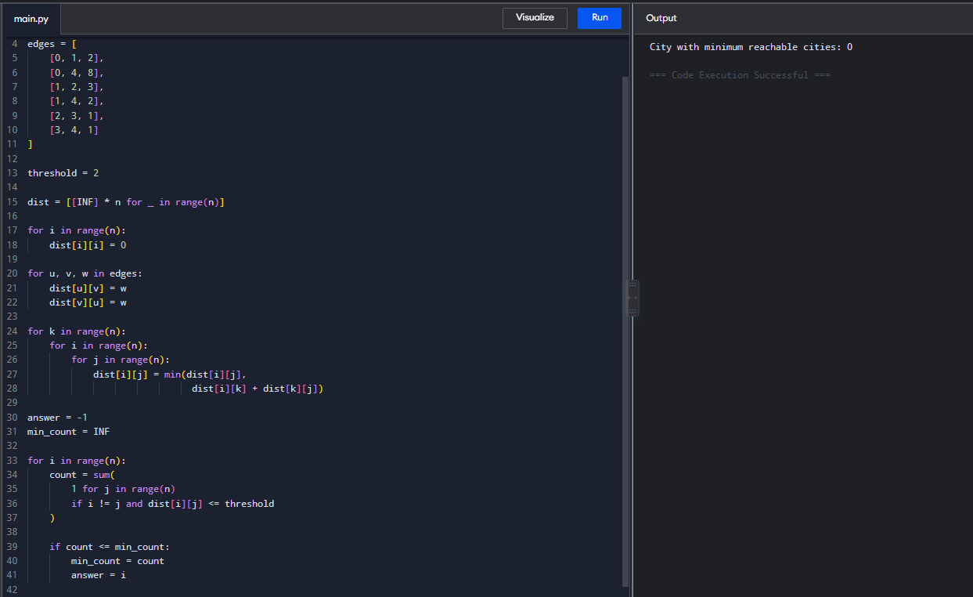
Time Complexity: O(n³)
Space Complexity: O(n²)

15, 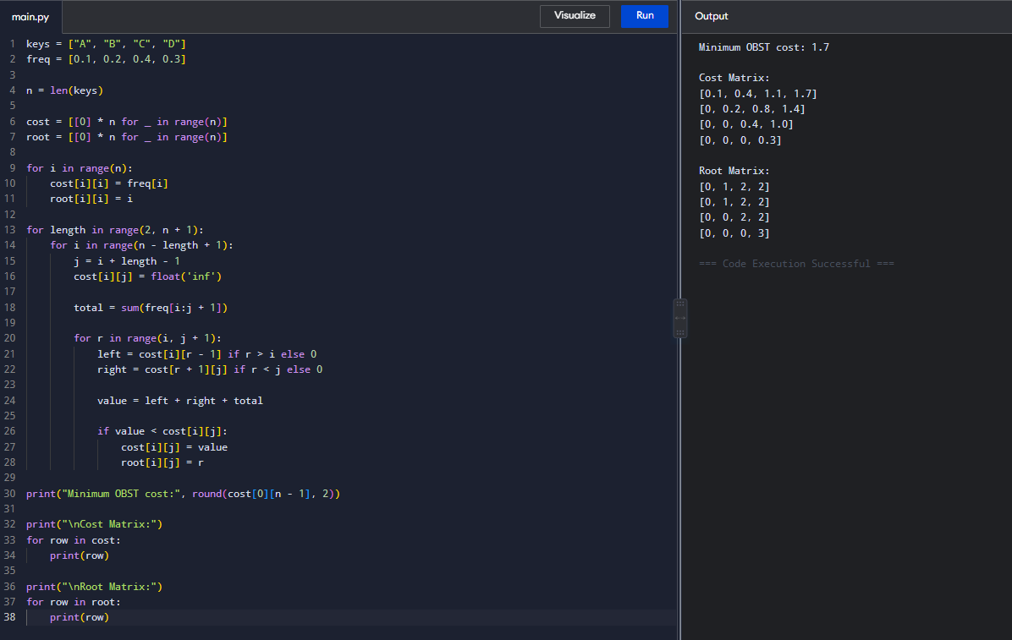
Time Complexity: O(n³)
Space Complexity: O(n²)

16, 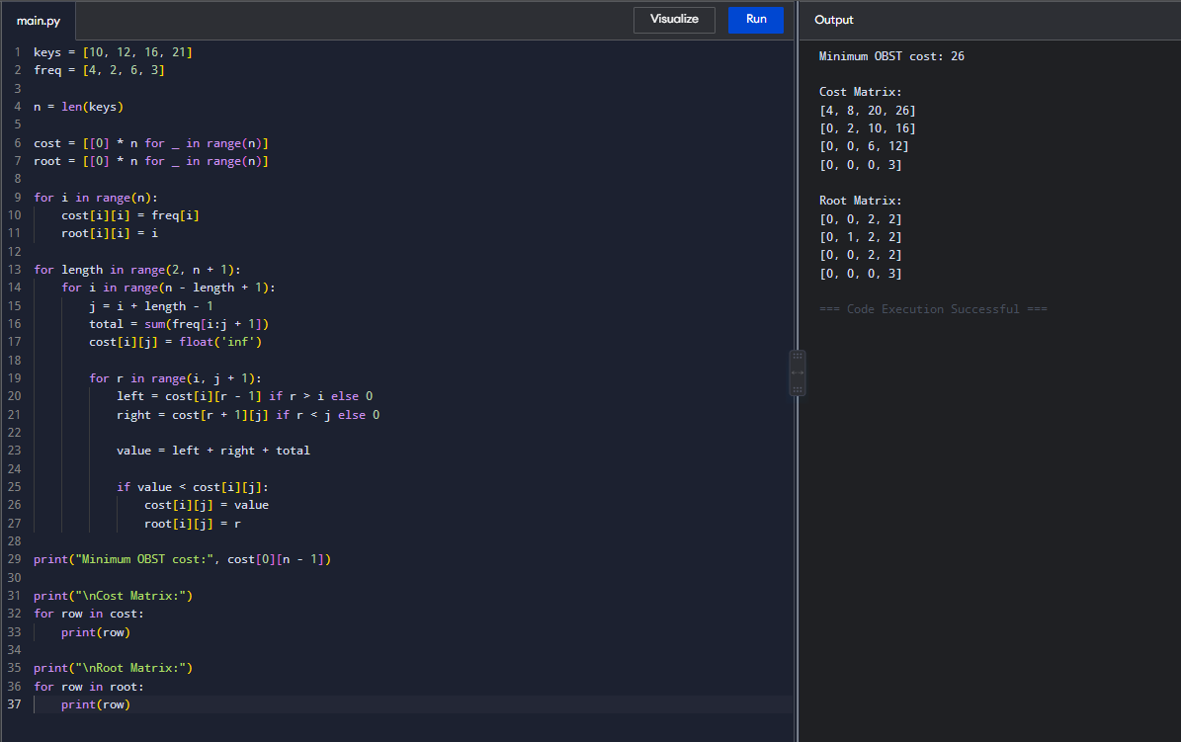
Time Complexity: O(n³)
Space Complexity: O(n²)
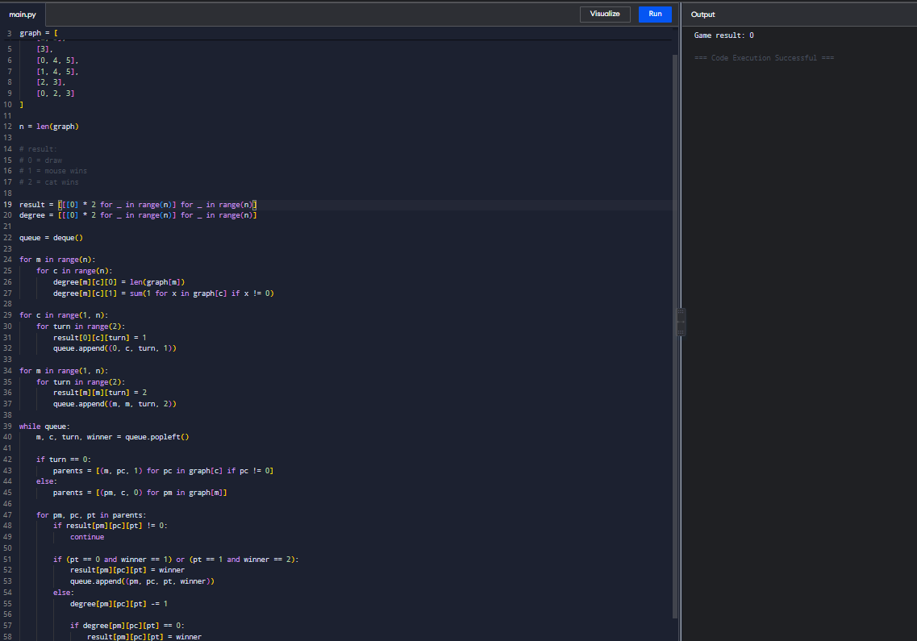
17,

Time Complexity: O(n³)
Space Complexity: O(n³)

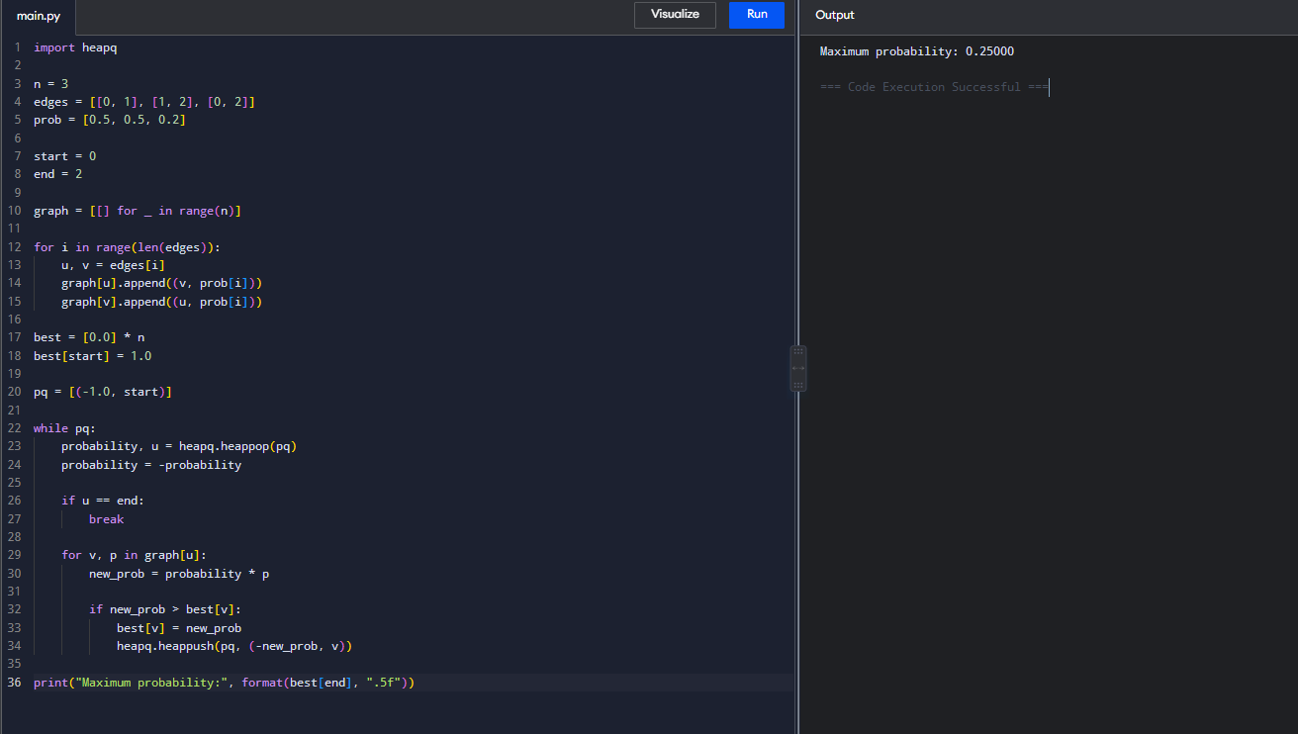
18,

Time Complexity: O((V + E) log V)
Space Complexity: O(V + E)

19, 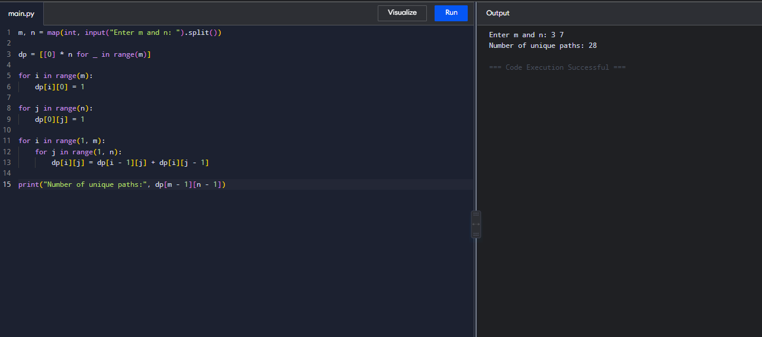
Time Complexity: O(m × n)
Space Complexity: O(m × n)

20,
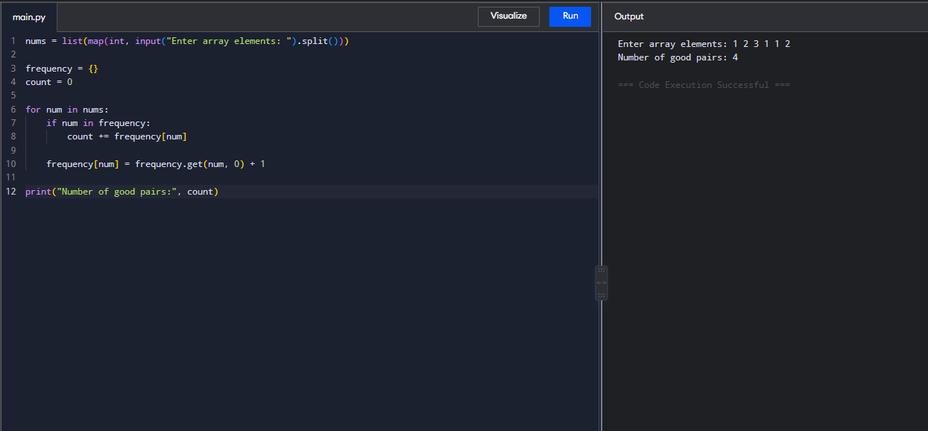
Time Complexity: O(n)
Space Complexity: O(n)

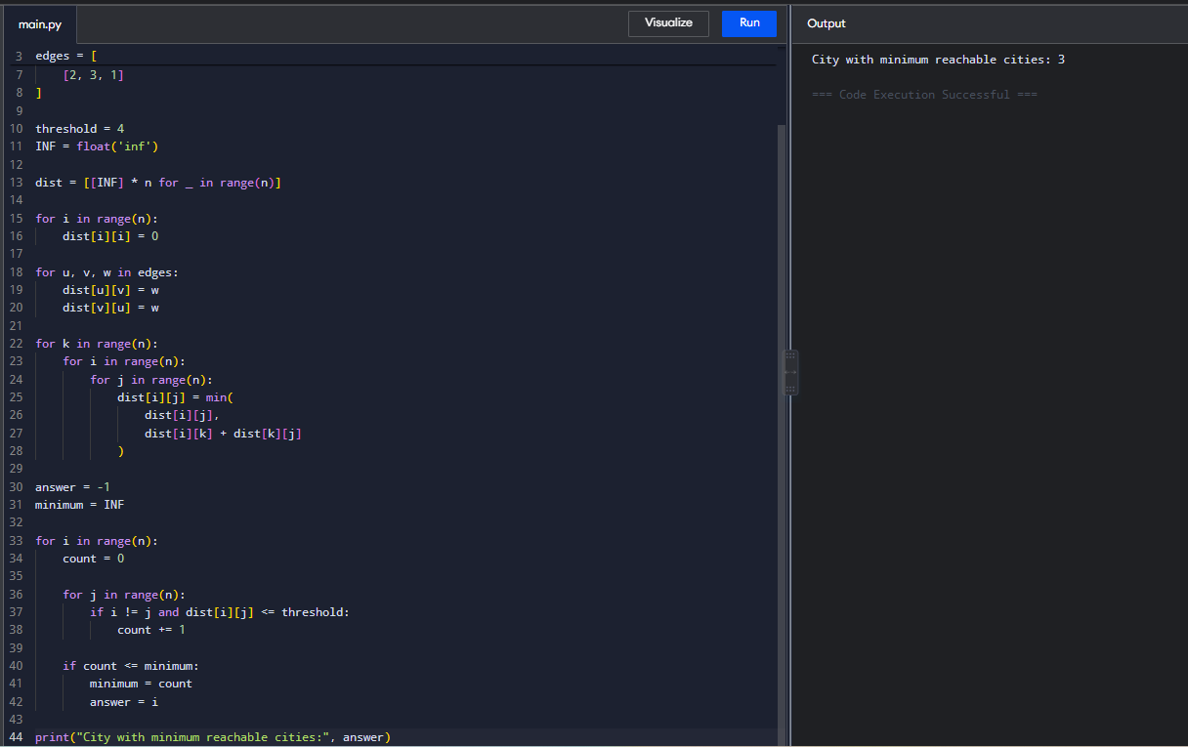
21,

Time Complexity: O(n³)
Space Complexity: O(n²)

22,
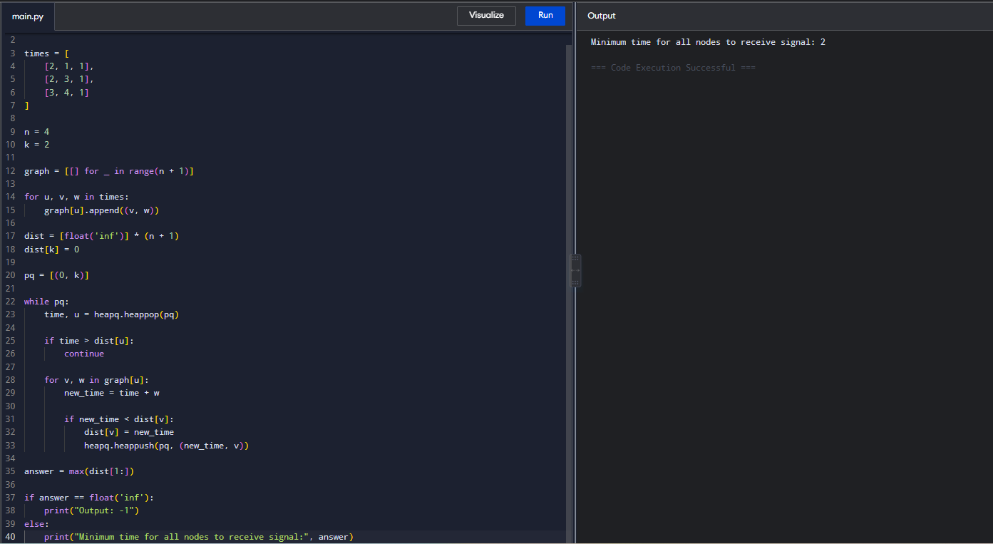
Time Complexity: O((V + E) log V)
Space Complexity: O(V + E)

